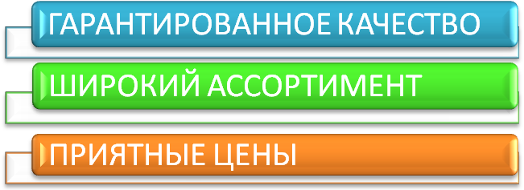
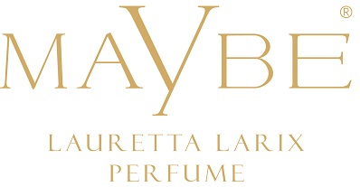
MaYbe Lauretta Larix Perfume - это:
Концентрация:
Женский парфюм 24% Мужской парфюм 24%

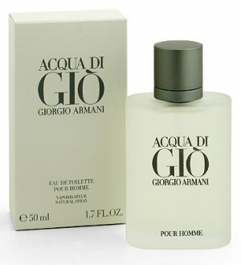  №201  Giorgio Armani “Aqua di Gio” | №202  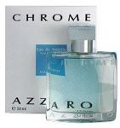  Azzaro  “Chrome” | №203  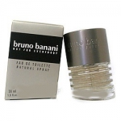  Bruno Banani  “ Men” | №204  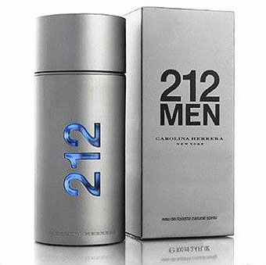  Carolina Herrera “212 Men” | №205  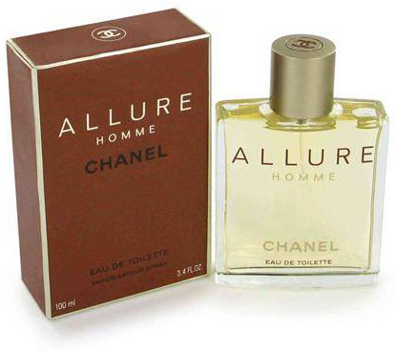  Chanel  “Allure Homme”
№206  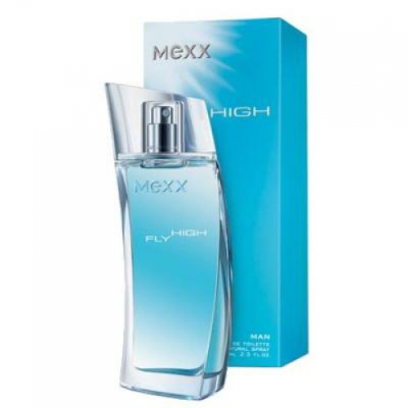  Mexx  “Fly High Man” | №207  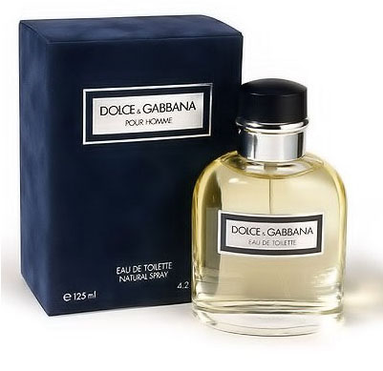  Dolce & Gabbana  “Pour Homme” | №208  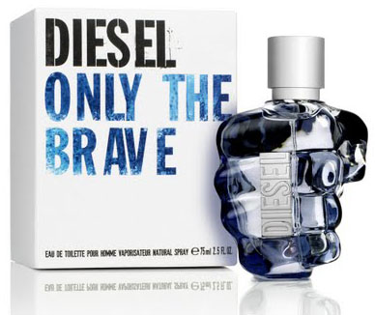  Diesel  “Only the Brave” | №209  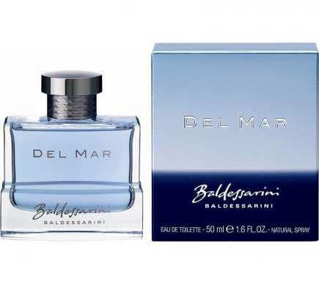  Hugo Boss  “Baldessarini  Del Mar” | №210  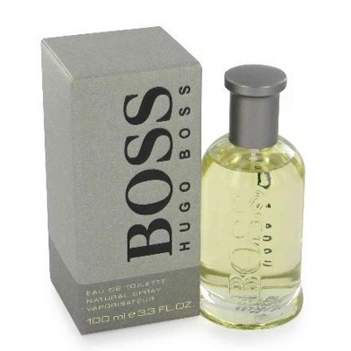  Hugo Boss  “Boss”
№214  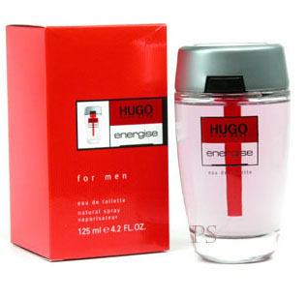  Hugo Boss  “Hugo Energise” | №215  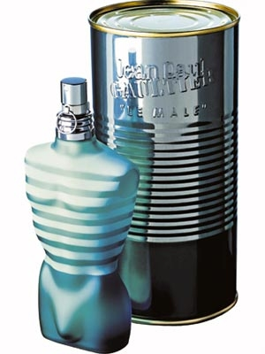  J.P. Gaultier  “Le Male” | №217  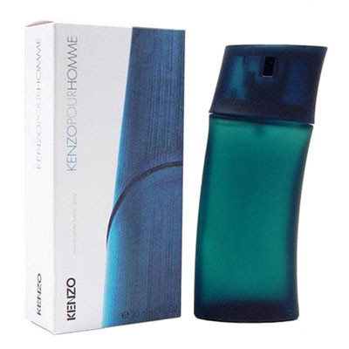  Kenzo  “Pour Homme” | №218  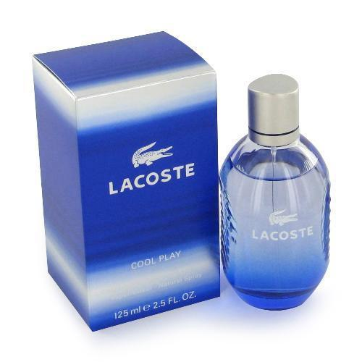  Lacoste  “Cool Play” | №219  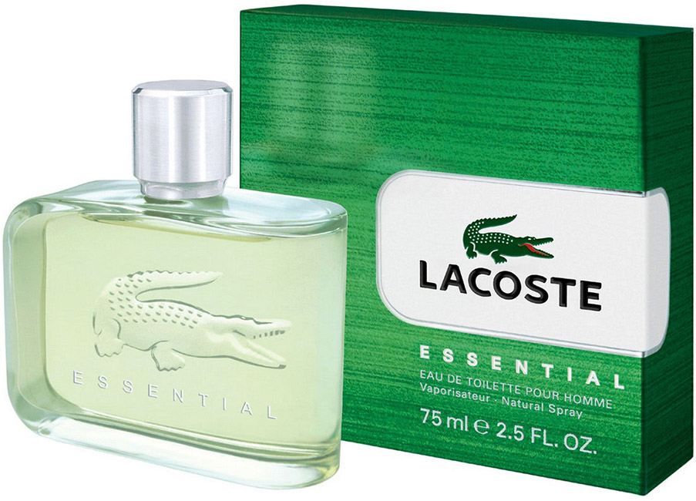  Lacoste  “ Essential”

№220  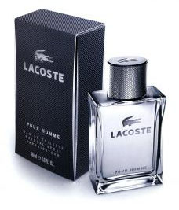  Lacoste  “Pour Homme” | №221  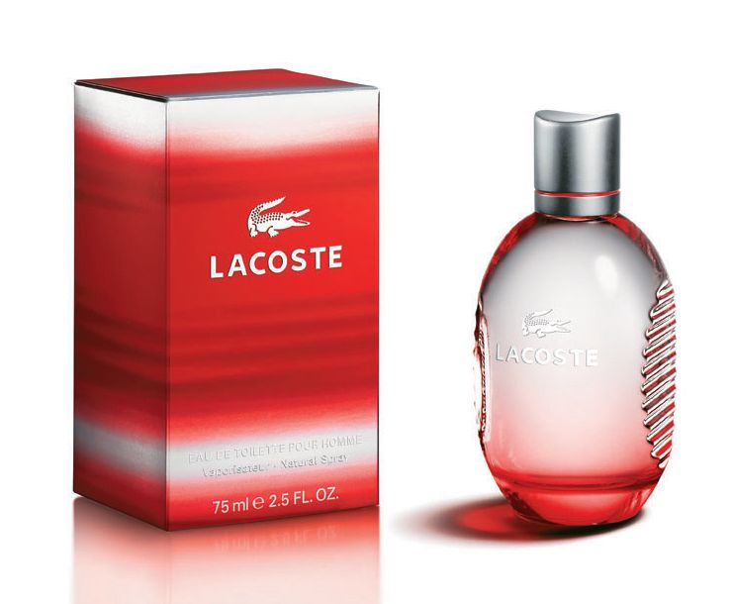  Lacoste  “Style in Play” | №222  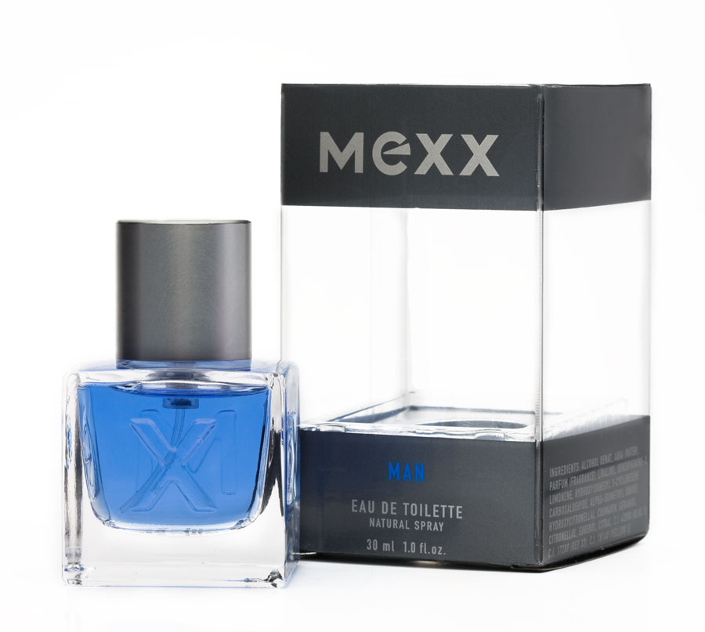  Mexx  "Mexx Man” | №223  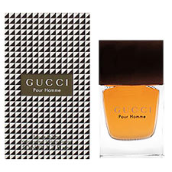  Gucci  “Pour Homme” | №224  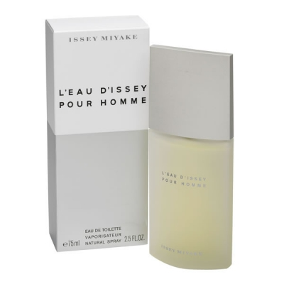  Issey Miyake “L´eau D´Issey Homme”
№225  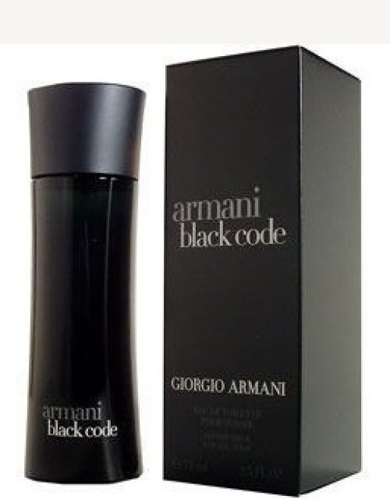  Giorgio Armani  “Black Code” | №226  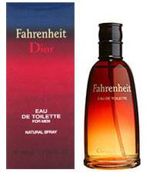  Christian Dior “Fahrenheit” | №227  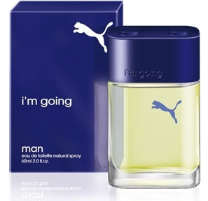  Puma  “I´m Going Man” | №229  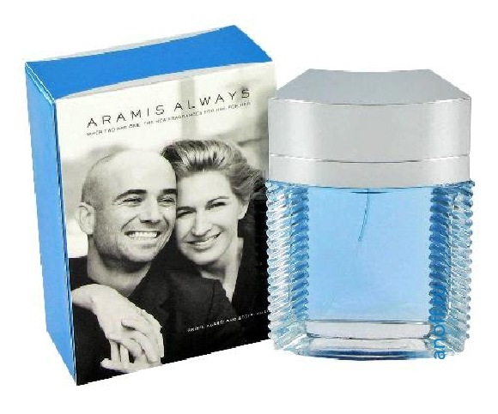  Aramis  “Always For Him” | №231  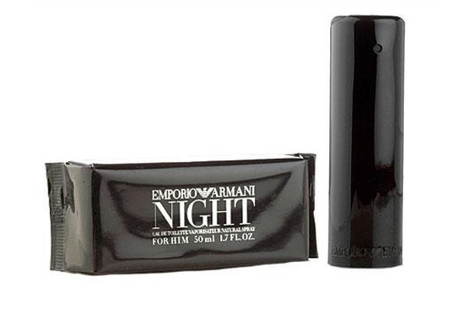  Giorgio Armani  “Emporio Armani Night He”
№232  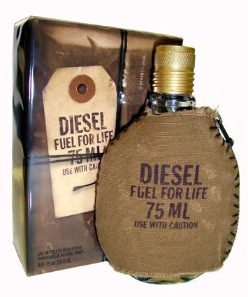  Diesel  “Fuel For Life” | №233  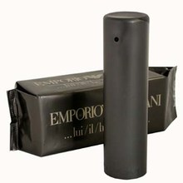  Giorgio Armani  “Emporio” | №235  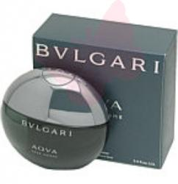  Bvlgari  “Aqua Pour Homme” | №237  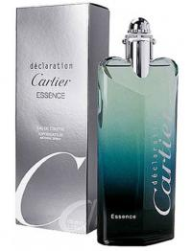  Cartier  «Declaration Essence” | №239  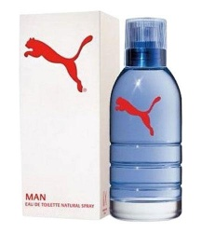  Puma  “Men”
№240  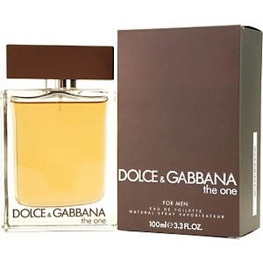  Dolce & Gabbana  “The One” | №241  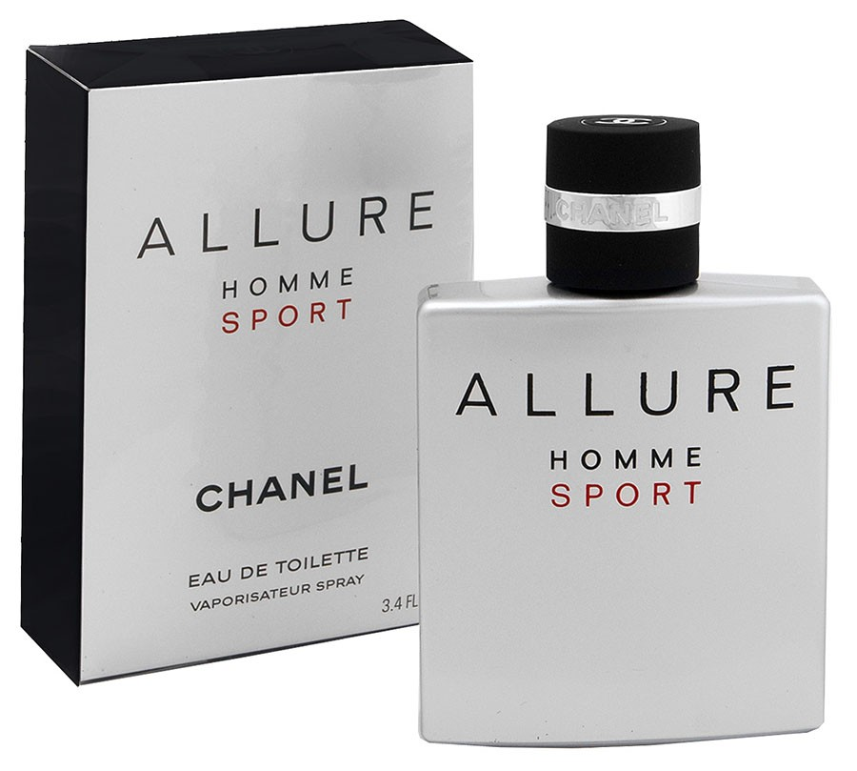  Chanel  “Allure Homme Sport” | №242  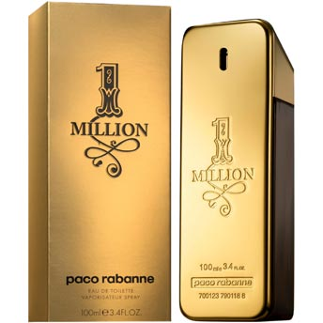  Paco Rabanne  “1 Million” | №243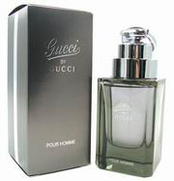  Gucci  “By Guci Men” | №244  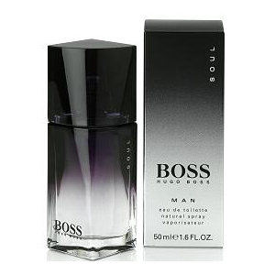  Hugo Boss  “Soul Men”

№101  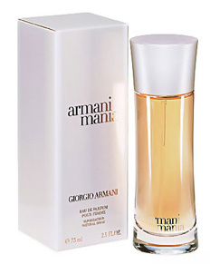  Giorgio Armani  “Mania” | №102  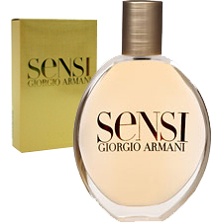  Giorgio Armani  “Sensi” | №103  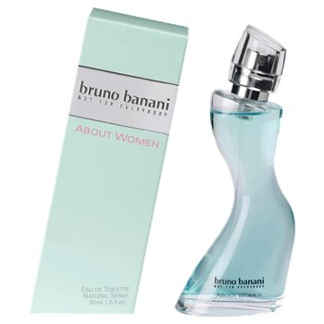  Bruno Banani  “About Woman” | №104  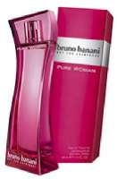  Bruno Banani  “Pure Woman” | №105  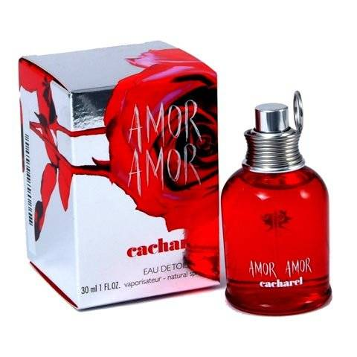  Cacharel  “Amor Amor”
№106  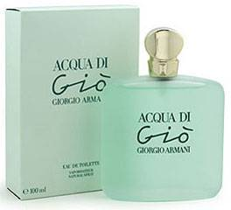  Giorgio Armani  “Aqua di Gio” | №107  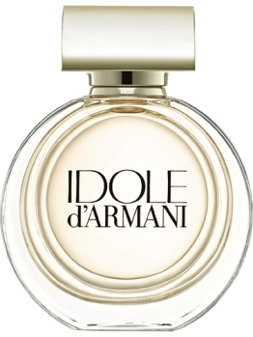  Giorgio Armani  “Idole d´Armani” | №108  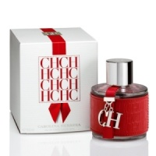  Carolina Herrera  “Carolina Herrera” | №109  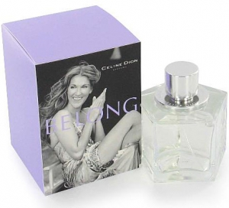  Celine Dion  “Belong” | №110  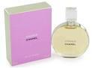  Chanel  “ Chance”
№111  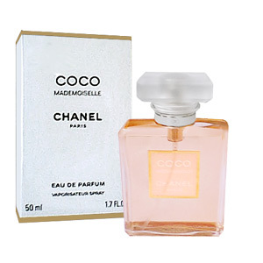  Chanel  “Coco Mademoiselle “ | №112  №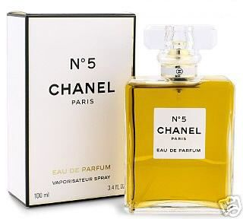  Chanel  “No. 5” | №113  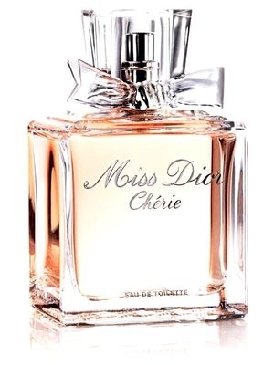  Christian Dior  “Miss Dior Cherie” | №115  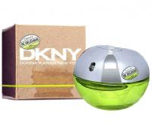  DKNY  “Be Delicious” | №116  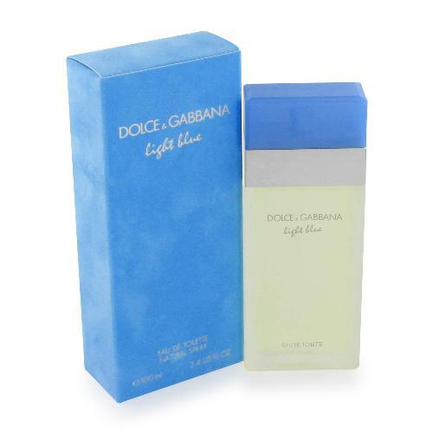  Dolce & Gabbana  “Light Blue”
№117  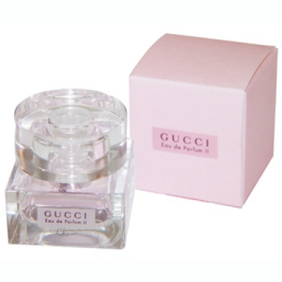  Gucci  „Eau de Parfum II" | №118  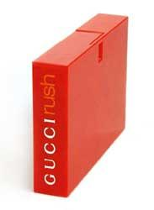  Gucci  “Rush” | №119  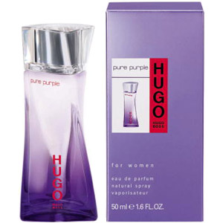  Hugo Boss  “Pure Purpl” | №120 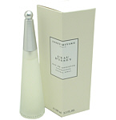  Issey Miyake  “L´eau d´Issey” | №122  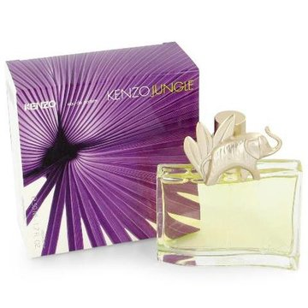  Kenzo  “Jungle Elephant”

№123  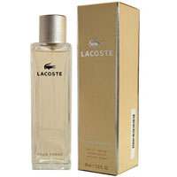  Lacoste  “Pour Femme” | №124  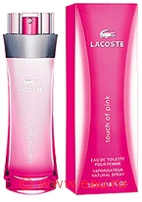  Lacoste  “Touch of Pink” | №125  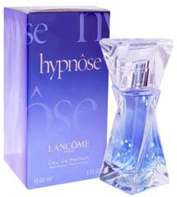  Lancome  “Hypnose” | №126  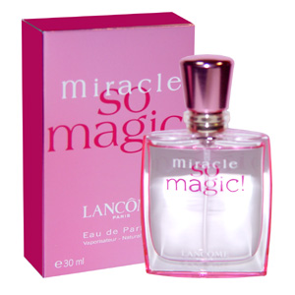  Lancome  “Miracle So Magic” | №127  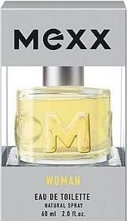  Mexx  “Woman”
№128  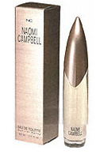  Naomi Campbell  “Naomi” | №129  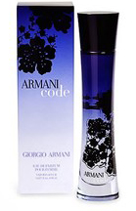  Giorgio Armani “Armani Code” | №130  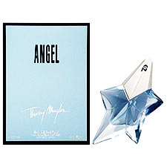  Thierry Mugler  “Angel” | №132  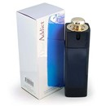  Christian Dior  “Addict” | №133  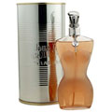  J.P.Gaultier “Classic”
№134  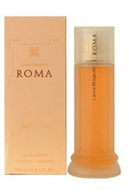  Laura Biagiotti “Roma” | №135  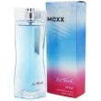  Mexx  “Ice Touch” | №137  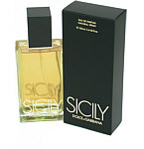  Dolce & Gabbana “Sicily” | №139  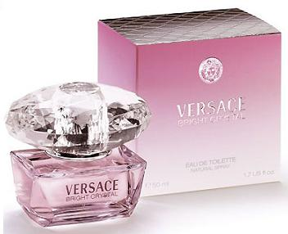  Versace  “Bright Christal” | №140  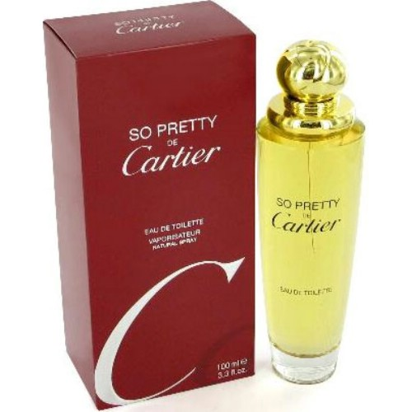  Cartier  “So Pretty”
№141  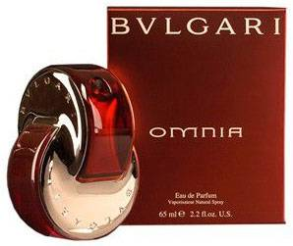  Bvlgari  “Omnia” | №142  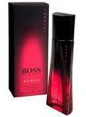  Hugo Boss  “Boss Intense” | №143  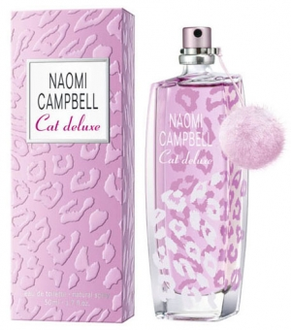  Naomi Campbell  “Cat Deluxe” | №144  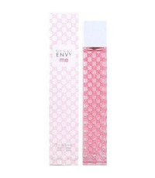  Gucci  “Envy Me” | №145  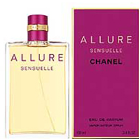  Chanel  “Allure Sensuelle”

№146  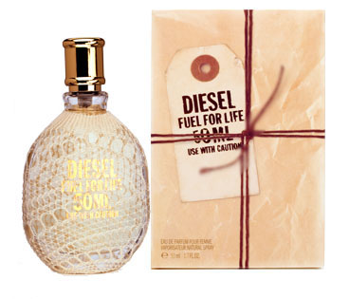  Diesel  “Fuel for Life” | №147  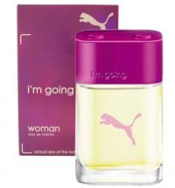  Puma  “I´m going Woman” | №149  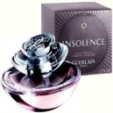  Guerlain  “Insolence” | №150  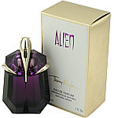  Thierry Mugler “Alien” | №151  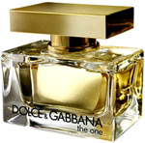  Dolce & Gabbana “The One”
№154  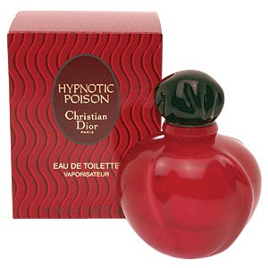  Christian Dior “Hypnotic Poison” | №155  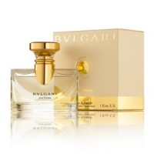  Bvlgari  “ Pour Femme” | №156  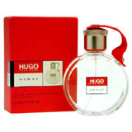  Hugo Boss  “Hugo Woman” | №158  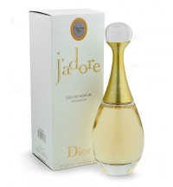  Christian Dior “J´Adore” | №161  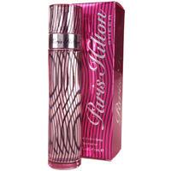  Paris Hilton  “Paris Hilton”
№163  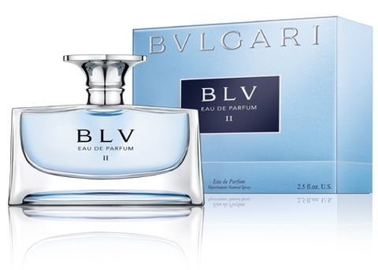  Bvlgari  “BLV” | №165  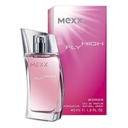  Mexx  “Fly High Women” | №166  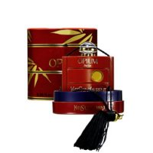  Yves Saint Laurent “Opium” | №168  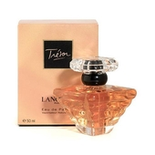  Lancome  “Tresor” | №169  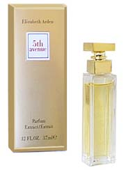  Elisabeth Arden  “5th Avenue”
№170  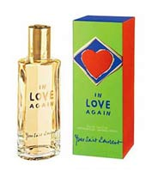  Yves Saint Laurent  “In love Again” | №172  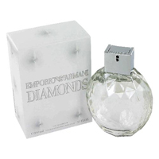  Emporio Armani “Diamonds” | №173  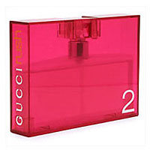  Gucci  “Rush 2” | №174  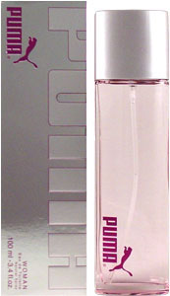  Puma  “Woman” | №175  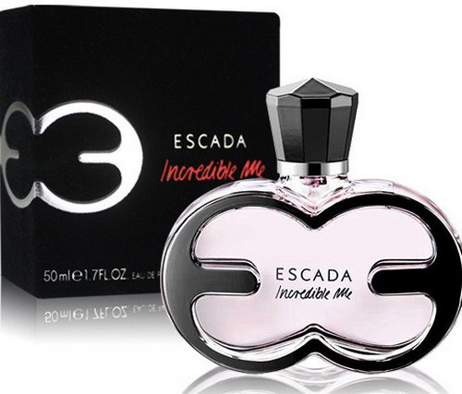  Escada  “Incredible Me”

№176  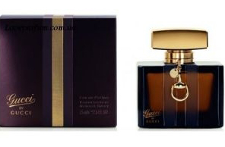  Gucci  “By Gucci Women” | №177  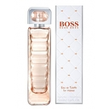  Hugo Boss “Orange” | №178  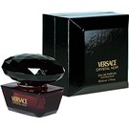  Versace  “Crystal Noir“ | №179  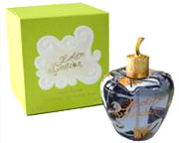  Llolita Llempicka “Le Premier Parfum“ | №180  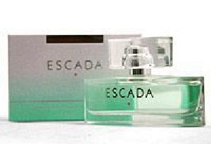  Escada  “Signature”
№181  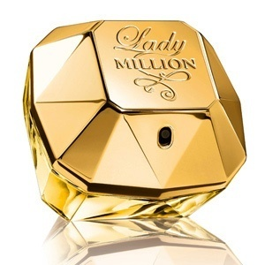  Paco Rabanne “Lady Million” | №182  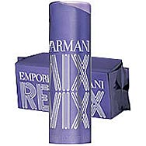  Giorgio Armani “Emporio Remix For Her” | New №114  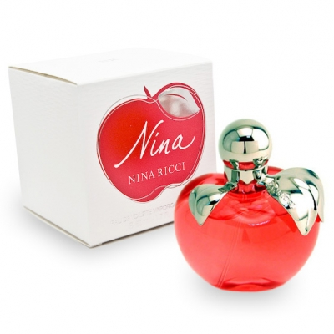Nina Ricci “Nina” | New №121  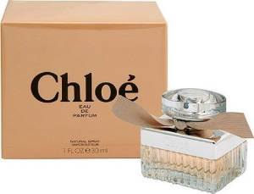Chloe “Cloe” | New№131  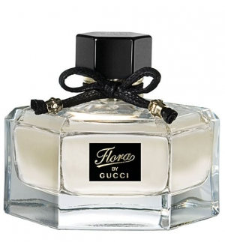 Gucci “Gucci By Gucci”
new№211  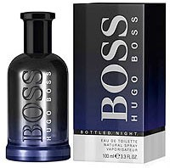  Hugo Boss “Bottled Night” | new№212  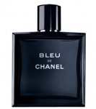  Chanel “Bleu De Chanel” | New№213  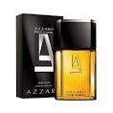  Azzaro “Pour Homme” | New№216  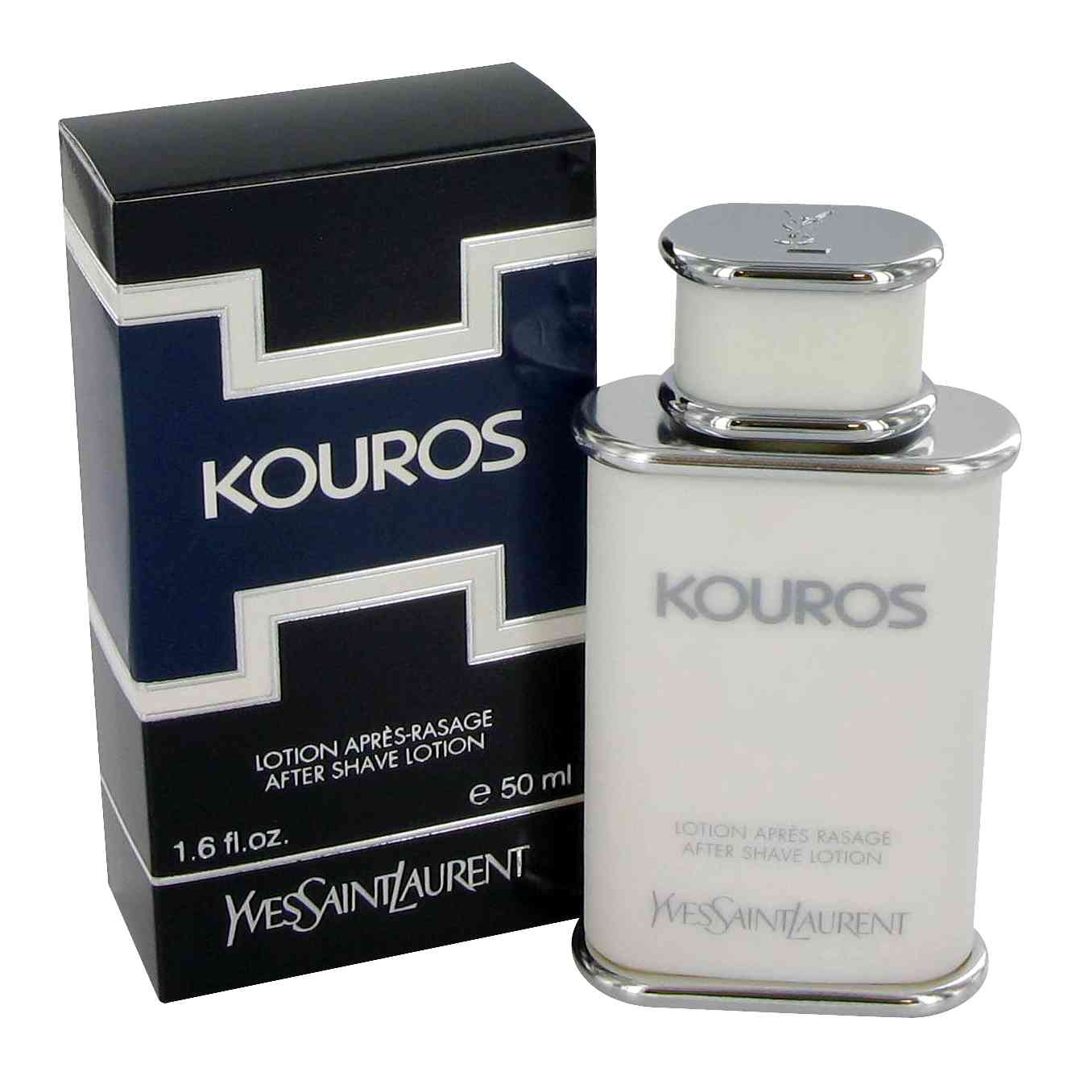Yves Saint Laurent “Pour Homme” | New№228  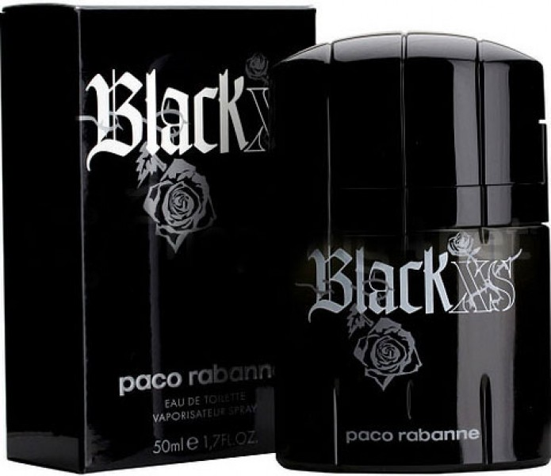  Paco Rabanne “Black XS”
New№136  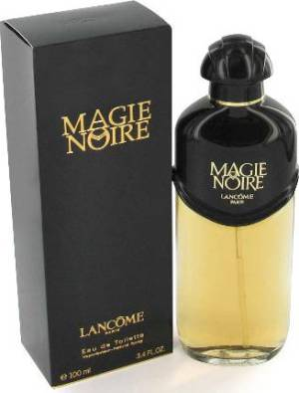 Lancome “Magie Noire” | New№138  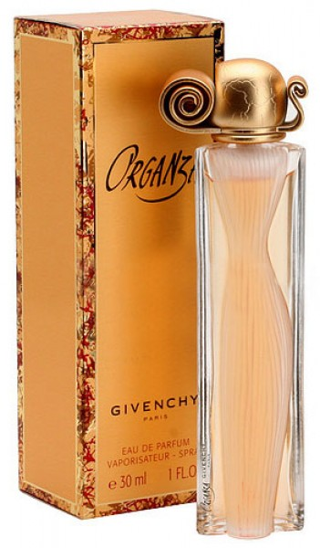 Givenchy “Organza” | New№148 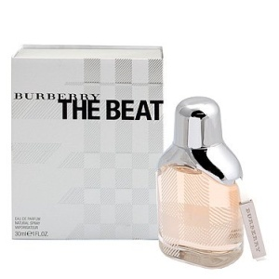  Burberry “The Beat” | New№152 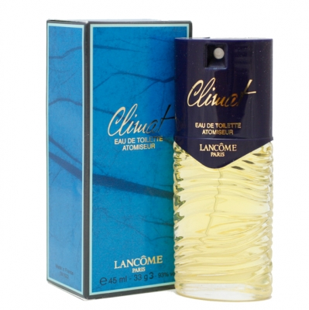  Lancome “Climat” | New№153  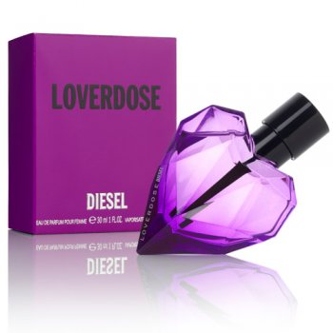Diesel “Loverdose”

